To copy files having specific patterns in name

* Having 1 digit nos in sequential manner like

File1.txt

File2.txt

File3.txt

File4.txt

1. Create the dataset similarly create the linked list like previously only
2. Now go to copy activity
3. Now go to source
4. Here for files in source select wildcard file path

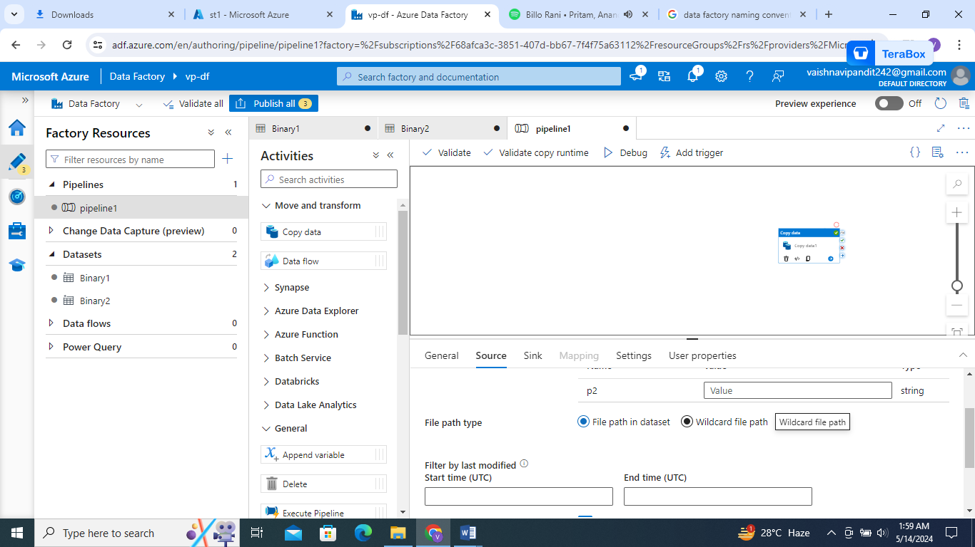

1. Add folder path

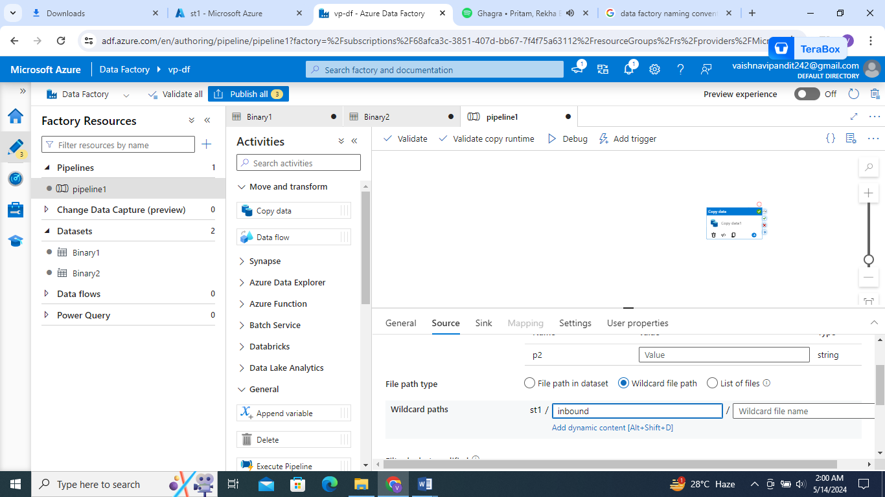

1. Add file?.txt in filename

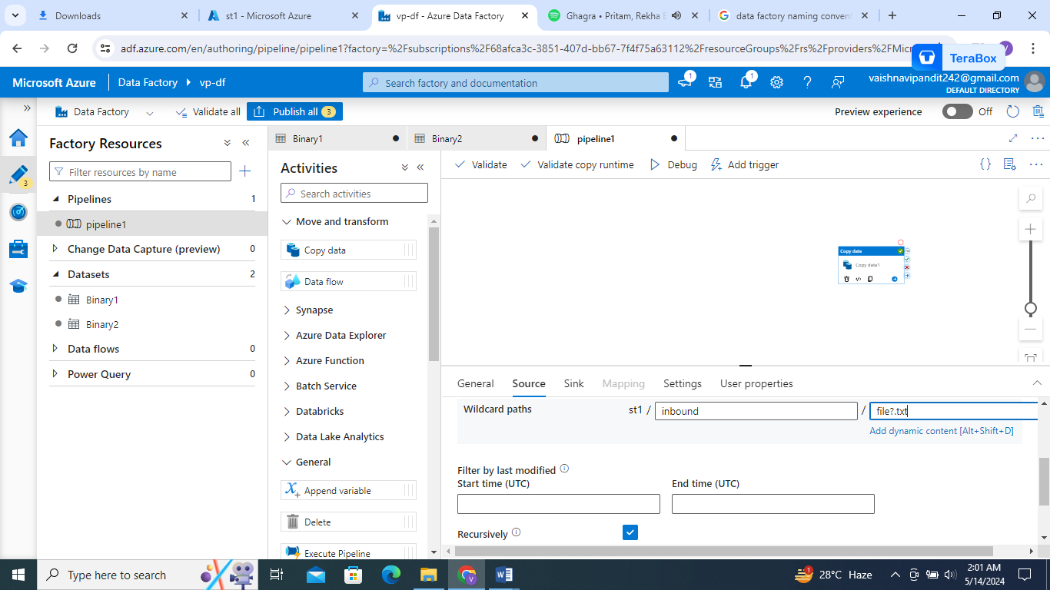

1. Add file?.txt as well in parameter value p2

And debug

* Now copy the files which are in the format

File1.txt

File234.txt

File90888.txt

For that do the similar as previous one just add file*.txt in the wildcard file path and the parameter value p2

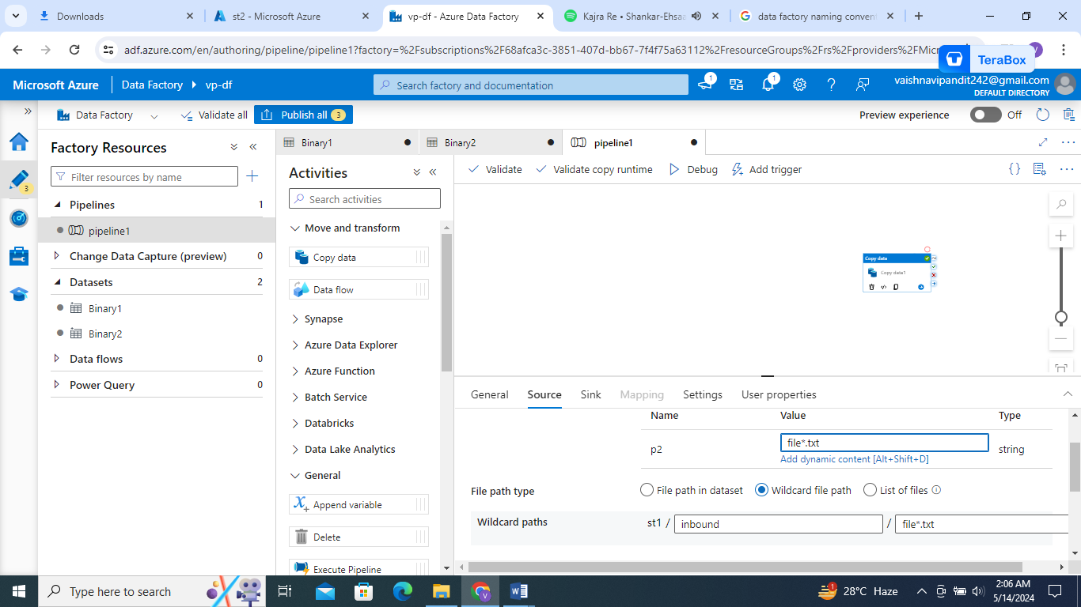

* Where we want the file from the todays date only but names can be different

Od_12052024.txt

Vp12052024.txt

Bp12052024.txt

Here do the similar thing just write *12052024* or create variable for utcnow and in wildecard path go to add dynamic function and add that variable like concat(‘*’,variable v1,’*’)

